USE CASE STUDY REPORT

Group No.: Group 22

Student Names: Nikhil Dharane and Shivani Deodhar

Executive Summary: This should be written when the study has concluded. State the goal of the study, the origin of the data, data processing, and data mining techniques. Summarize the findings and recommendations. Please always use “Times New Roman” font throughout with size14pt for headings and size 12pt for body text. There will be a deduction if report does not follow this template and guidelines. The length of your report should NOT exceed 15 pages (excluding R code which can be put in Appendix)!

Background and Introduction

We wanted to choose a case study such that all predictive and classification models can be implemented. This will enhance will data mining skills. This gives us a great platform to use majority of the models taught in class. This is HR Analytics and carried out frequently by major organizations. Employee attrition is one of the biggest challenges that the companies face.

The cost of replacing employees is very high. Organizations need to search, hire and train new employees. Loss of experienced workers especially high performers is difficult to manage and is negatively related to the success and performance of organizations. There are several factors that lead to attrition. While it may not be easy to control all the factors, it may not be worthwhile to investigate those factors that seem controllable. Factors such as average number of hours spend per month by the employees, salary, promotions, job rotation, number of projects are a few which are easier to manage.

If we can extract cut-off levels for some of the above-mentioned factors through our analysis, then we should be able to have a better understanding about the factors that are responsible for the employees leaving the company prematurely. Thus, this will help in creating a feature selection model which will list out all the possible attributes responsible for the employee attrition.

All these losses and issues generated due to the employee attrition, makes it very important to have a solution-based system to predict employee attrition so as to avoid it, which can then be used by higher officials as a backup plans to avoid sudden business road blocks (Rashid and Jabar; 2016). This is where we bring technology into the picture.

II. Data Exploration and Visualization
We checked the data for missing values. Luckily our data has no missing value or inconsistencies.
There are many continuous variables, we can have a look at their distribution and create a grid of pair plots but that would be too much code to see the correlation as there are a lot of variables. Rather, we can create a seaborn heatmap of numeric variables and see the correlation. The variables which are not poorly correlated (i.e. correlation value tend towards 0), we will pick those variables and move forward with them and will leave the ones which are strongly correlated (i.e. correlation value tend towards be 1).

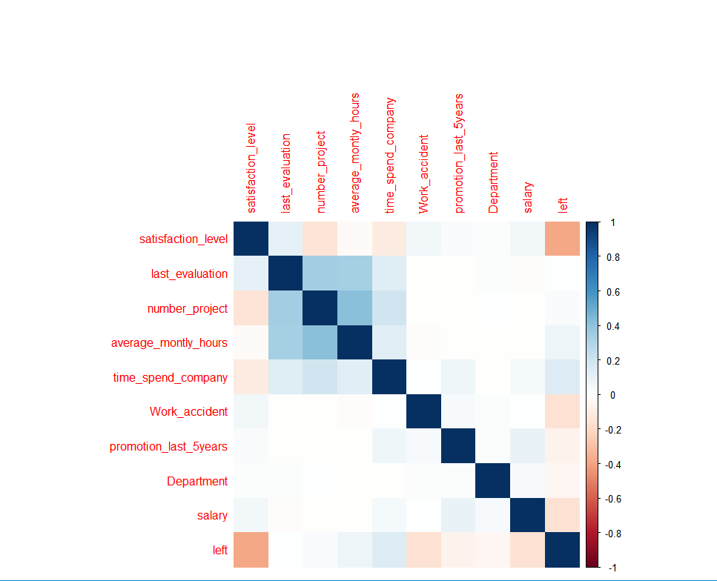

From the above heat map, we can now see which variables poorly correlated and which ones are strongly correlated.

III. Data Preparation and Preprocessing
> summary(dataset)
satisfaction_level last_evaluation number_project average_montly_hours time_spend_company Work_accident
Min. :0.0900 Min. :0.3600 Min. :2.000 Min. : 96.0 Min. : 2.000 Min. :0.0000
1st Qu.:0.4400 1st Qu.:0.5600 1st Qu.:3.000 1st Qu.:156.0 1st Qu.: 3.000 1st Qu.:0.0000
Median :0.6400 Median :0.7200 Median :4.000 Median :200.0 Median : 3.000 Median :0.0000
Mean :0.6128 Mean :0.7161 Mean :3.803 Mean :201.1 Mean : 3.498 Mean :0.1446
3rd Qu.:0.8200 3rd Qu.:0.8700 3rd Qu.:5.000 3rd Qu.:245.0 3rd Qu.: 4.000 3rd Qu.:0.0000
Max. :1.0000 Max. :1.0000 Max. :7.000 Max. :310.0 Max. :10.000 Max. :1.0000
promotion_last_5years Department salary left
Min. :0.00000 Min. : 1.00 Min. :1.000 Min. :0.0000
1st Qu.:0.00000 1st Qu.: 1.00 1st Qu.:1.000 1st Qu.:0.0000
Median :0.00000 Median : 4.00 Median :2.000 Median :0.0000
Mean :0.02127 Mean : 4.34 Mean :1.595 Mean :0.2381
3rd Qu.:0.00000 3rd Qu.: 7.00 3rd Qu.:2.000 3rd Qu.:0.0000
Max. :1.00000 Max. :10.00 Max. :3.000 Max. :1.0000

ENCODING
We replace the categorical and the non-numerical variables with numerical variables and replace Yes and No in (dataset$Left) response variable with 1 and 0. We convert the categorical variable department with numerical dummy variables and we assign the variable salary with various levels and values.

FEATURE SCALING AND DATA NORMALIZATION

So we used the feature scaling to standardize the range of the independent variables or the features of the data with highly varying magnitudes, units and range

To test the models created for the analysis, the ideal approach of data mining is to distribute the data into groups of test and train data and then run the analysis on the test data based on the observations from the trained data.
Correlation has been used in the past to see the relationship between the employee attrition and other attributes like employee satisfaction and demographics attributes, which is a very useful technique to find out the relationships between the predictor and the predicting variable, and also between the different predictor variables in a dataset.

We proceed to apply factor analysis - PCA to our data, a statistical procedure to find the linearly uncorrelated variables, which are called principle components.

cm
y_pred
0 1
0 2286 0
1 714 0

IV. Data Mining Techniques and Implementation

To build a prediction model, we need to first split the available data into test data and training data.
We will first set aside a dataset of 20 observations, pulled out randomly from the existing dataset. This test dataset will be used to run the final predictive model.
The dataset is also divided into training dataset (80%), which will be used to build the models, and testing dataset, which will be used to test the models. . We will train the model on training data and predict the results on test data.
We will use the most popular techniques and models here to make our predictions. The goal is to achieve the highest possible accuracy and test the predictive technique on the test data. If our technique is accurate then our prediction results on the test data (which is randomly drawn from the available data) will generate exactly the same values.
The models that will be considered are:
- Logistic Regression
- Linear Discriminant Analysis
- XG- Boost Using K-fold Cross Validation Model
- Random Forest Model
- Support Vector Machine Model

- Logistic Regression:
Logistic regression [12-13] is a statistical method which is used to analyse a dataset which consists of one or more independent variables that determine an outcome. The outcome has only two values i.e. either yes or no or other binary outcomes like 1 or 0, true or false. It was developed to estimate the likeliness of a binary response based on more than one independent feature. Logistic regression permits anyone to say that the existence of a risk factor enhances the probability of a given case. Like every other regression analysis, logistic regression is also a predictive analysis. In general, it is used for the description of data and to delineate the relationship between a dependent variable or feature and more than one nominal or ordinal independent variables.
Linear regression models with lm() function are great when you have a continuous response variables. But in our case, the response variable left is a factor (categorical) variable. We will use glm() function to see the relationship between the dependent and the independent variables, and then use the predict() function on the test data to get the probability for the next employee to leave.
The result is
summary(classifier)

Call:
glm(formula = left ~ ., family = binomial, data = training_set)

Deviance Residuals:
Min 1Q Median 3Q Max
-2.2383 -0.6623 -0.4055 -0.1201 3.0725

Coefficients:
Estimate Std. Error z value Pr(>|z|)
(Intercept) -3.13311 0.17431 -17.974 < 2e-16 ***
satisfaction_level -1.02117 0.02718 -37.578 < 2e-16 ***
last_evaluation 0.09877 0.02854 3.461 0.000539 ***
number_project -0.36859 0.02935 -12.560 < 2e-16 ***
average_montly_hours 0.22306 0.02869 7.775 7.57e-15 ***
time_spend_company 0.40128 0.02538 15.812 < 2e-16 ***
Work_accident -0.55631 0.03566 -15.600 < 2e-16 ***
promotion_last_5years -0.19509 0.04010 -4.865 1.15e-06 ***
Departmenthr 0.25467 0.14964 1.702 0.088776 .
DepartmentIT -0.15068 0.13721 -1.098 0.272129
Departmentmanagement -0.38809 0.17675 -2.196 0.028110 *
Departmentmarketing 0.12520 0.14760 0.848 0.396304
Departmentproduct_mng -0.10433 0.14573 -0.716 0.474021
DepartmentRandD -0.39922 0.16040 -2.489 0.012810 *
Departmentsales -0.00693 0.11568 -0.060 0.952228
Departmentsupport 0.07687 0.12327 0.624 0.532881
Departmenttechnical 0.12263 0.12005 1.021 0.307036
salarylow 1.93374 0.14344 13.481 < 2e-16 ***
salarymedium 1.38383 0.14418 9.598 < 2e-16 ***
---
Signif. codes: 0 ‘***’ 0.001 ‘**’ 0.01 ‘*’ 0.05 ‘.’ 0.1 ‘ ’ 1

(Dispersion parameter for binomial family taken to be 1)

Null deviance: 13172 on 11998 degrees of freedom
Residual deviance: 10272 on 11980 degrees of freedom
AIC: 10310

Number of Fisher Scoring iterations: 5

The confusion matrix obtained from conducting Logistic Regression is :
cm
y_pred
0 1
0 2117 169
  - 458 256

From the above we can say that satisfaction_level, last_evaluation, number_project, average_montly_hours, time_spend_company, Work_accident, promotion_last_5years and salary are the prime variables that contribute towards the dependent variable Left and are highly responsible for the employee attrition. We were able to figure the independent variables responsible from the associated z-values that tend to be less than 0.05 as shown below in the significance of the codes

Signif. codes: 0 ‘***’ 0.001 ‘**’ 0.01 ‘*’ 0.05 ‘.’ 0.1 ‘ ’ 1

- Linear Discriminant Analysis (Supervised Learning)
LDA is a part of the supervised Learning and qualifies as the feature extraction technique and not the feature selection technique.
LDA is a dimensionality reduction technique. It is pre-processing step for pattern classification and project a dataset onto a lower dimensional space.
Similar to PCA, we are interested in the axes that maximize the separation between multiple classes.

Also to explain further there is also an explicit correlation between the number of linear discriminants and information of the dependent variable. That is K-1 Linear discriminants where K is the total number of classes in the dependent variables

So now converting to a training dataset composed of linear discriminants we will get 1 linear discriminant, so this one new extracted feature will separate most classes.

When we use the predict function for LDA o the training dataset we will get the matrix and later we use another function as.dataframe to convert it to dataframe

Linear discriminant analysis (LDA) is a generalization of Fisher’s linear discriminant, a method used to find a linear combination of features that characterizes or separates two or more classes of objects or events.
Our data primarily has two classes of variables - factor (response variable) and numeric (all other predictor variables).
The confusion matrix obtained is:
cm
y_pred
0 1
0 2590 0
1 16 394

- XG Boost Using K fold Cross Validation Model

XG Boost is an extreme gradient boosting technique with decision trees so the feature scaling is totally unnecessary. It is a very powerful model
especially if you work on large data sets.
It will offer you a very high-performance while being fast to execute.
And speaking of performance and execution speed it is important to remind that XG boost is the most powerful implementation of gradient boosting in terms of model performance and execution speed.
Therefore it's very important for you to have it.

Generalized Boosted Regression Model is a generalized boosting algorithm that can deal with both multiclass classification and regression problems. GBMs train one tree at a time, so they can take longer to train. Training more trees with GBMs increases the likelihood of overfitting but GBMs help to reduce bias.
Gradient boosting or XG Boost is a very popular machine learning algorithm and is extensively used in projects for structured or tabular data. It is a technique for regression and classification in which a prediction model is produced. The implementation of this algorithm is very fast and scalable. In gradient boosting, classification is done sequentially, and the new predictors learn from the mistakes that are made by the previous predictors. As it learns from the mistakes done previously, it takes less time to classify and give the results. Another important thing to remember is that it is very important to provide the stopping criteria i.e. when the classifier or predictor should stop classifying so that there is no overfitting.
After fitting all the models, we will pick the one that provide us with the highest accuracy rate.

The Results are :

cm
y_pred
FALSE TRUE
0 2277 9
- 52 662

$Fold01
[1] 0.9841667

$Fold02
[1] 0.9866667

$Fold03
[1] 0.985

$Fold04
[1] 0.9841535

$Fold05
[1] 0.9883333

$Fold06
[1] 0.985

$Fold07
[1] 0.99

$Fold08
[1] 0.9783333

$Fold09
[1] 0.99

$Fold10
[1] 0.9875

> accuracy

[1] 0.9859153

This is the model with the highest accuracy obtained.

- Random Forest Model

Random forests add an additional layer of randomness to bagging. For constructing trees, random forests classify and split each node by using the best among a subset of predictors randomly chosen at that node.
This method of classification performs well and is seen to be robust against overfitting. Random forests are ensembles of decision trees, which means it combines many decision trees and this reduces the risk of overfitting.
Random forests are designed to handle both cases when the response variable is either a factor variable or a continuous variable. In our dataset, the response variable is left, which is a factor variable.
The Random forest works on Bagging principle. It is an ensemble of Decision Trees. The bagging method is used to increases the overall results by combining weak models.
The Bayesian Optimization was used for hyperparameter tuning. In Random forest, the tuning parameter are mtry, no. of trees and node size, hence these were used for the tuning using Bayesian Optimization.

Confusion Matrix and Statistics

Reference
Prediction 0 1
0 2282 4
1 63 651

Accuracy : 0.9777
95% CI : (0.9717, 0.9827)
No Information Rate : 0.7817
P-Value [Acc > NIR] : < 2.2e-16

Kappa : 0.9366

Mcnemar's Test P-Value : 1.382e-12

Sensitivity : 0.9731
Specificity : 0.9939
Pos Pred Value : 0.9983
Neg Pred Value : 0.9118
Prevalence : 0.7817
Detection Rate : 0.7607
Detection Prevalence : 0.7620
Balanced Accuracy : 0.9835

'Positive' Class : 0
Here we obtain an accuracy of 97%, which is less than the XG Boost Model.

- Support Vector Machine Model

A Support Vector Machine (SVM) is a classifier which is defined by a separating plane or a separating line. In 2D space, this algorithm generates an output which is a line that divides the data into two parts with different classes on the either side of the line (say for example class 0 and class 1). The implementation of the SVM algorithms is done using a kernel in practice. In linear SVM, the plane learns by transforming the problem using linear algebra. Optimization procedure is used to solve the SVM model.

The confusion matrix found is :
cm
y_pred
0 1
0 2286 0
1 714 0
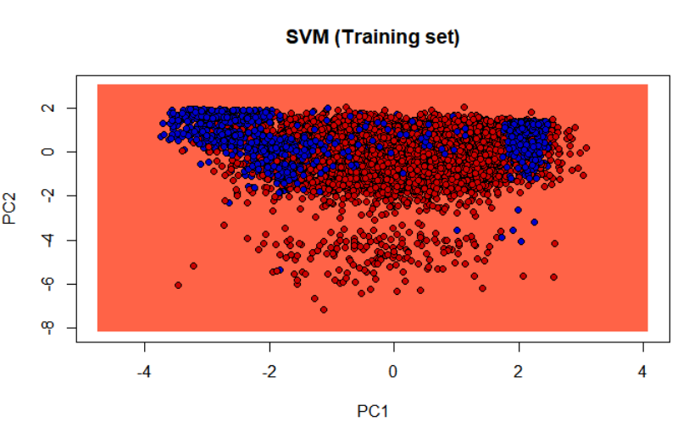
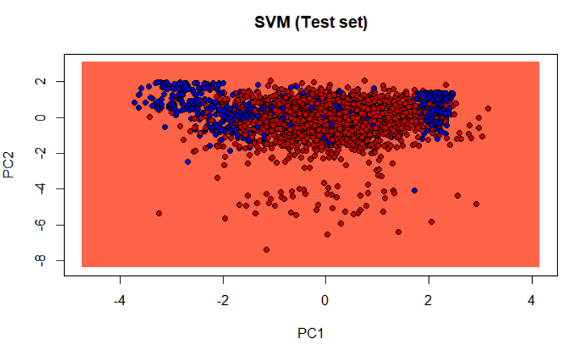

V. Performance Evaluation
Present performance evaluation for all data mining techniques explored in your study and select the best approach and explain why it is the best. Please ALWAYS divide your data into training set and validation set, and use validation set to evaluate the performance. If using pruned decision trees, please separate your data set into training, validation, and test. You should use performance measures such as lift chart, ROC curve, confusion matrix, prediction accuracy measures (MAE, Mean Error, MPE, MAPE, RMSE), classification accuracy measures (error rate, accuracy, sensitivity, specificity, false discovery rate, false omission rate, etc.).

VI. Discussion and Recommendation
Provide discussion of the overall approach, including advantages and shortcomings. Based on your results, make recommendations for solution, potential improvement, etc.

VII. Summary
Summarize your use case study.

Appendix: R Code for use case study
Please show the R code you generated for the use case study. Please do not show results here, only the code.http://127.0.0.1:23097/graphics/plot_zoom_png?width=1600&height=822

